**GUI Project – User’s Manual**Edit the document below, delete the instructions, and submit this document for grading.

DroneDogs User Guide

Prepared by [Jember Tadelo]

# INTRODUCTION

This program will help you to order hotdog from drone dog.

# DIRECTIONS

1. Start the app
2. Enter the number of beef dogs, pork dogs, turkey dogs etc

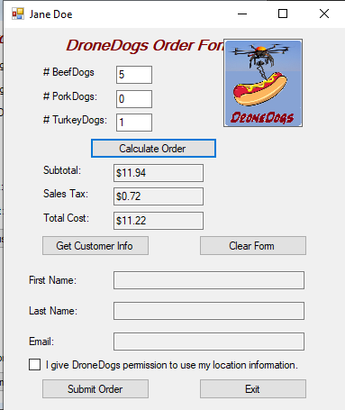

# KEY TERMS

This section should alphabetically list and define key terms from the Program (e.g. the labels on each data entry field, etc.)

* Beef dogs: the number of beef dogs ordered
* Pork dogs : the number of pork dogs ordered
* Turkey dogs: the number of turkey dogs ordered
* Calculate order: used calculate the order
* Sub total : the total price of the order
* Sales tax: the sales tax price
* Total cost: the total cost of the order
* Get customer info: to get the customer info
* Clear form: used to clear the form
* Check box: give the permission before submit the order
* Submit order: used to submit the order
* Exit: used to exit the program